**CTGuard**

**QUALITY PLAN**

1. **Overview**

CTGuard Mobile Application is a safety commuting application which can help passengers immediately report abusive PUV drivers they may encounter. Summary features are:

* QR Code Scanner - Scan QR Code of PUV and automatically shows information of the vehicle and send to user’s chosen contact/s. Such informations are:
  + Plate Number
* Public and Premium Taxi(Grab Car and Uber) Operator
* Public and Premium Taxi(Grab Car and Uber) Company Name
* Live Tracking of the passenger’s location – Passenger’s location can be tracked by his/her chosen contacts.
* Report Button – Enables the passenger to report abusive and violating drivers.
* Danger Button - Signal a Distress Call to the user’s desired contacts, the apps admin, and government authorities.
* End Trip Button – Manually ends trip(session).

1. **Scope**

This Quality Plan of this system will cover the performance of the following modules:

|  |  |
| --- | --- |
| **ITEM** | **Quality Check** |
| QR Code Scanner | Scans a QR code correctly even with lens flash or glare |
| GPS Tracking | Tracks user accurately in real time |
| Video Recording | Records properly and is able to be saved locally |
| SMS | SMS containing critical information (i.e., coordinates, link for live tracking) of the sender are sent to the designated contact (s) |
| Application and API Communication | APIs must correctly process and display the requested data by the application |
| Distress call | Must correctly contact proper authority (i.e., 911) |
| Complaint | Must indicate correct details regarding the vehicle’s plate number and its operator, type of complaint, and the date |

1. **Constraints and Limitations**

* Mobile Data – Mobile Data is dependent to Data subscription and the Telco’s Data speed
* SMS transmission – SMS delay is dependent to the telco’s
* Sound Quality of Calls – Quality of Calls is dependent to the Mobile Device’s Signal strength
* Video and/or Audio quality – Quality is dependent to the mobile device’s Video and audio recording
* App response – performance is dependent to the mobile device’s specification
* GPS tagging accuracy – accuracy is dependent on mobile device’s location.
* API to Database Communication – Transmission speed between the API and Database cannot be controlled.

1. **People**
   1. **Client**

The National Council for Commuters Protection (NCCP) will help in populating and ensuring data accuracy data regarding taxi vehicles

* 1. **Team Members (Name /Roles)**

|  |  |  |
| --- | --- | --- |
| Name: | Email | Roles |
| Maraya, Lorin |  |  |
| Barriga, Jacques |  | Quality Analyst |
| Catuncan, Franz | fccatuncan@gmail.com | Quality Control |
| Costales, Angelo |  | Document Specialist |
| De Mesa, Franzchel | pfpdemesa@gmail.com | Quality Analyst |
| Dizon, Dan |  | Document Specialist |
| Intia, April | aprilrose12intia@gmail.com | Quality Control |
| Maniquis, Jenny | jenny.maniquis@gmail.com | Quality Analyst |
| Mojica, Albert | albertjohnmojica@gmail.com | Quality Tester |
| Pilares, Dwight | dcpilares@gmail.com | Quality Tester |

* 1. **Roles and Responsibilities (Role / Qualification / Responsibilities)**

|  |  |  |
| --- | --- | --- |
| Name: | Role: | Responsibilities: |
|  |  |  |
| Barriga, Jacques | DB Analyst/Quality Analyst (Team Distress Module) | Oversee that the project database is of industry quality and fully functional |
| Catuncan, Franz | Android Programmer/Quality Control  (Team Distress Module) | Supervises the project prototype development |
| Costales, Angelo | Android Programmer/Document Specialization (Team Ligtas Sakay) | Supervises the project prototype development |
| De Mesa, Franzchel | DB Analyst/Quality Analyst (Team Ligtas Sakay) | Oversee that the project database is of industry quality and fully functional |
| Dizon, Dan | Web Developer/Document Specialization (Team Ligtas Sakay) | Oversee that the project team accomplishes all project-related tasks on-time |
| Intia, April | Web Developer/Quality Control (Team Distress Call) | Oversee that the project prototype meets the set functions and requirements |
| Maniquis, Jenny | Network Admin/Quality Analyst (Team Ligtas Sakay) | Ensure that the project team accomplishes all project-related tasks on-time |
| Mojica, Albert | Project Manager/Quality Tester (Team Distress Module) | Ensure that the project team accomplishes all project-related tasks on-time |
| Pilares, Dwight | Project Manager/Quality Tester (Team Ligtas Sakay) | Ensure that the project team accomplishes all project-related tasks on-time |

1. **Quality Objectives**

|  |  |  |  |
| --- | --- | --- | --- |
| **Objective** | **Action** | **Metric** | **Target** |
| Increase Application Launch Response Time |  | Seconds to load | Less than or equal to 5 seconds |
| Minimize Application Failure |  | Number of App Crashes every 10 attempts | Zero app crashes |
| Increase QR code Scanner accuracy |  | Seconds to Capture QR code | Less than or equal to 3 seconds |
| Increase Android API Compatibility |  | Minimum of API Compatibility | Minimum of API level 10 |
| Minimize distress module failures |  | Number of send failures every 10 attempts | Zero send failures |

1. **Quality Assurance Checkpoints – Reviews**

**Peer Review**

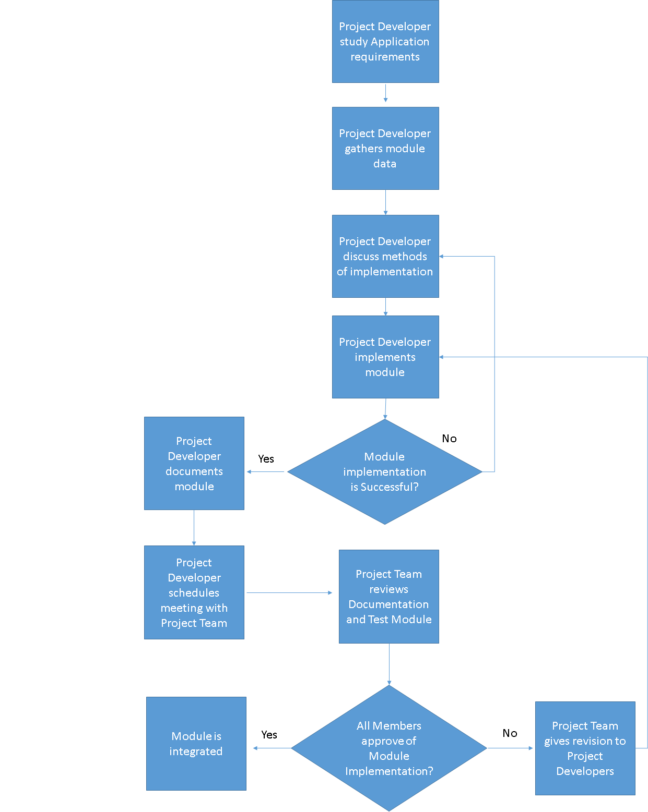

1. **Deliverable (table form)**

**[Deliverable / Schedule / Technique / Participants / Communication Medium / Remarks]**

|  |  |  |  |  |
| --- | --- | --- | --- | --- |
| **Deliverable** | **Schedule** | **Participants** | **Communication Medium** | **Remarks** |
| **Software Requirements Specification (SRS)** | **1 week** | **CityGuard** | **Formal Meeting** |  |
| **Software Architectural Design (SADD)** | **1 week** | **CityGuard** | **Formal Meeting** |  |
| **Software Design Document (SDD)** | **1 week** | **CityGuard** | **E-mail** |  |
| **Software Test Plan** | **1 week** | **CityGuard** | **E-mail** |  |
| **Software Usability Test Plan** | **1 week** | **CityGuard** | **E-mail** |  |
| **Documentation Review** | **1 week** | **CityGuard** | **E-mail** |  |